**Date: 20th September 2019**

**DMDD Assignment 2**

Query 1: Authors in California

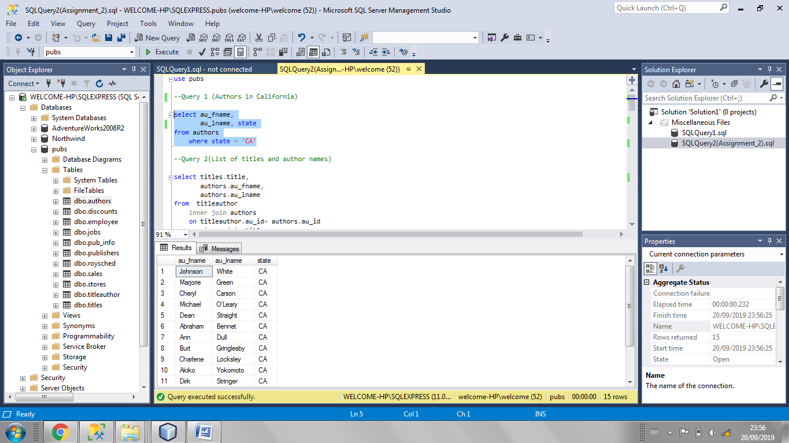

Query 2: List of titles and author names

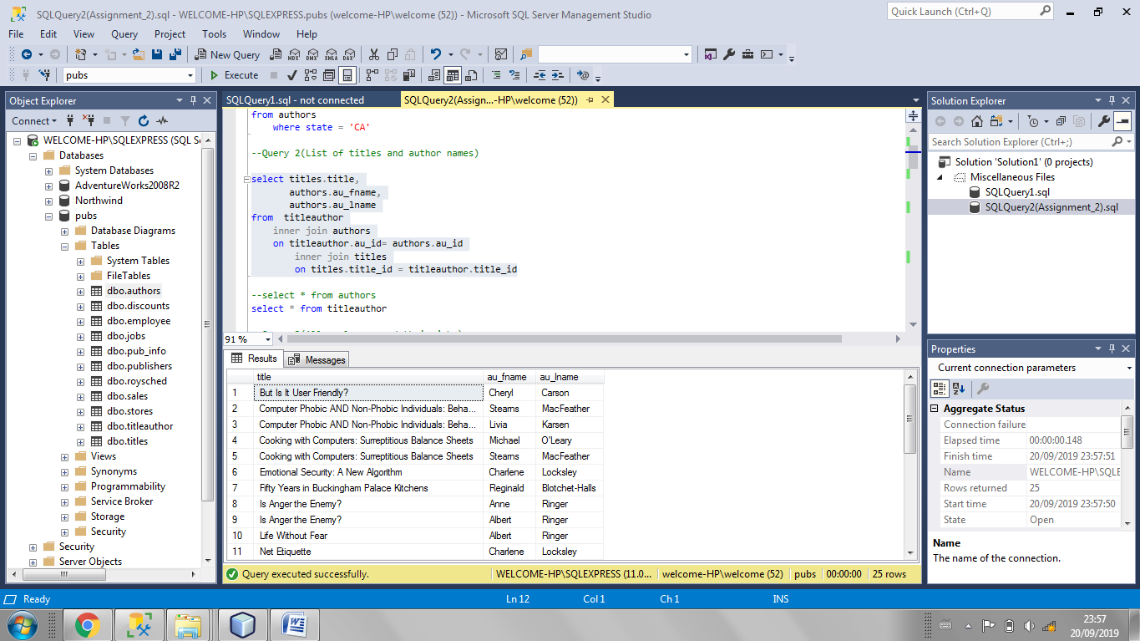

Query 3: All employees and their jobs

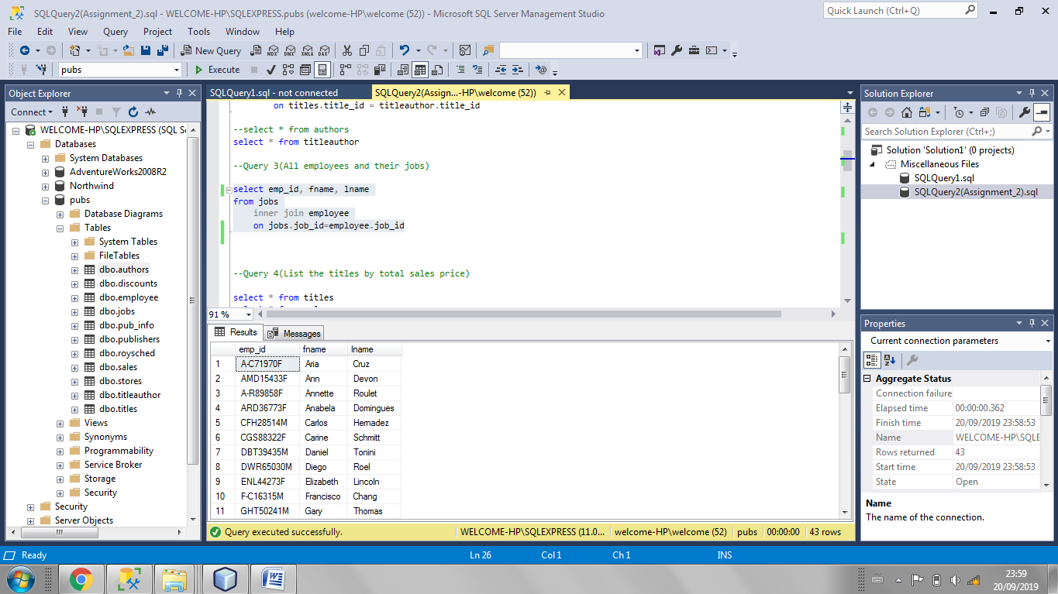

Query 4: List the titles by total sales price

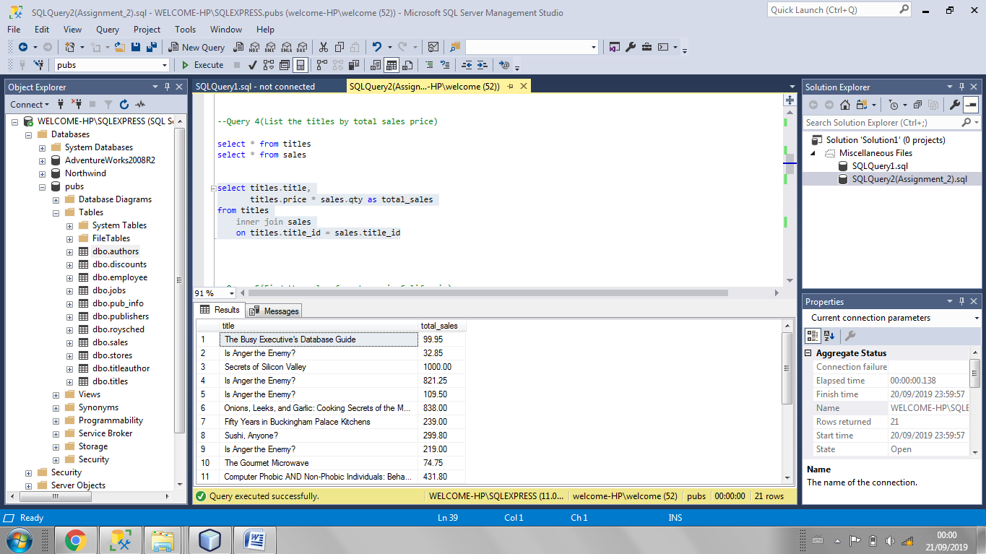

Query 5: Find the sales for stores in California

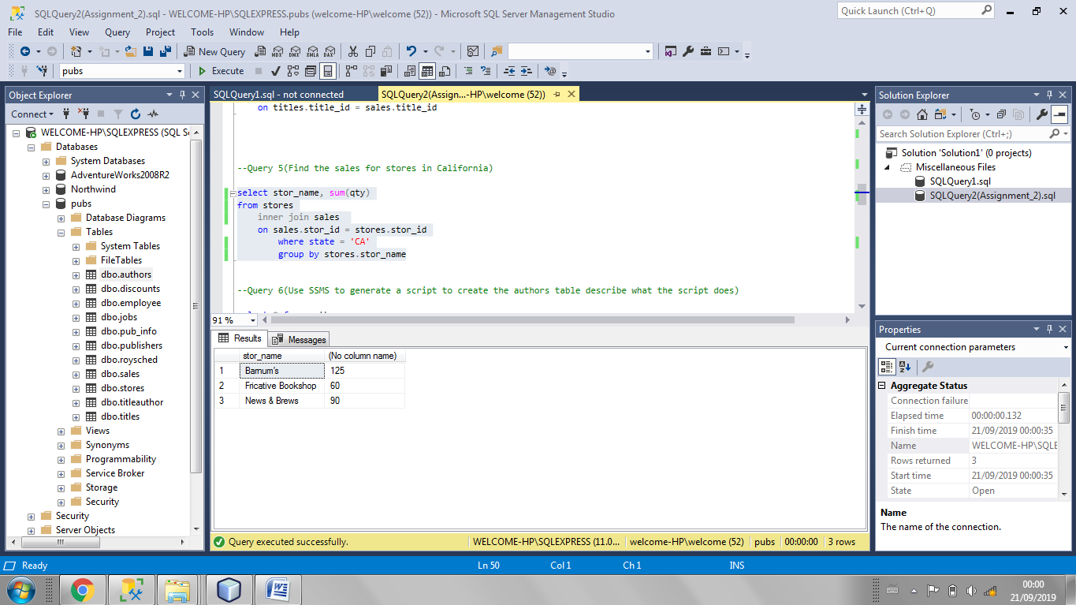

Query 6: Use SSMS to generate a script to create the authors table describe what the script does.

1. To create a Script we must right click on the table authors
2. Select the Script Table as
3. Select CREATE_TO
4. Select New Query Editor Window
5. The Script to the code is generated

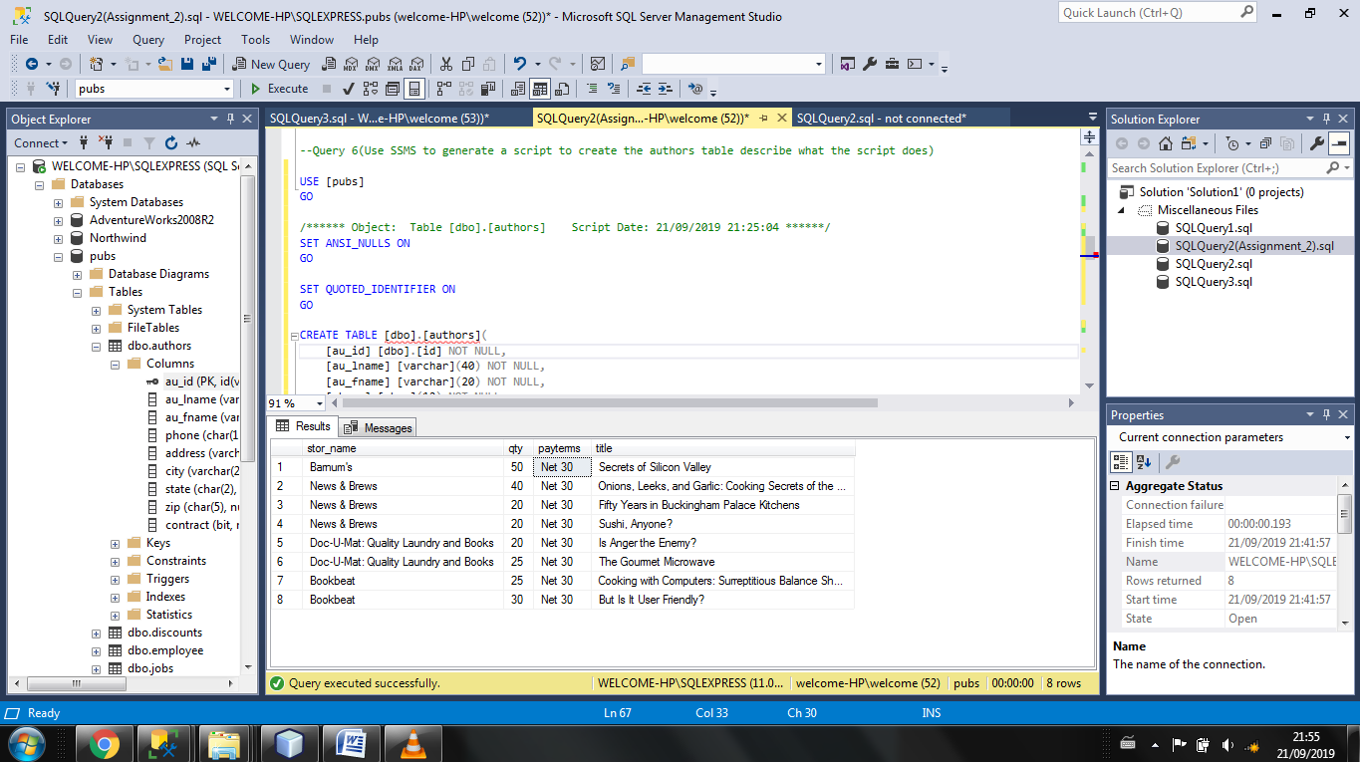

Query 7: Describe what the au_id is using for a data type

Data Type au_id

au_id in authors is a user defined data type.

au_id is assigning an ID number to the author and if of the type id(varchar(11)) .

au_id is the primary key to the author table.

To create a user defined data type:

1. Select Programmability in database
2. Select type
3. Select New
4. Set parameters

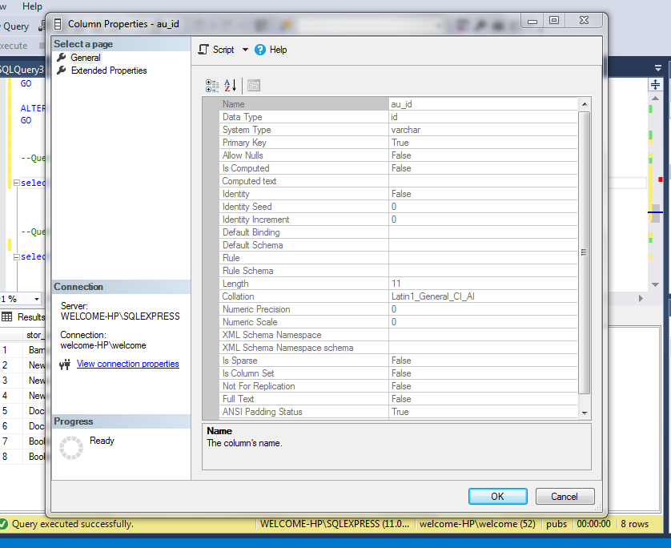

Query 8: Use SSMS to generate a script to create the authors table describe what the script does.

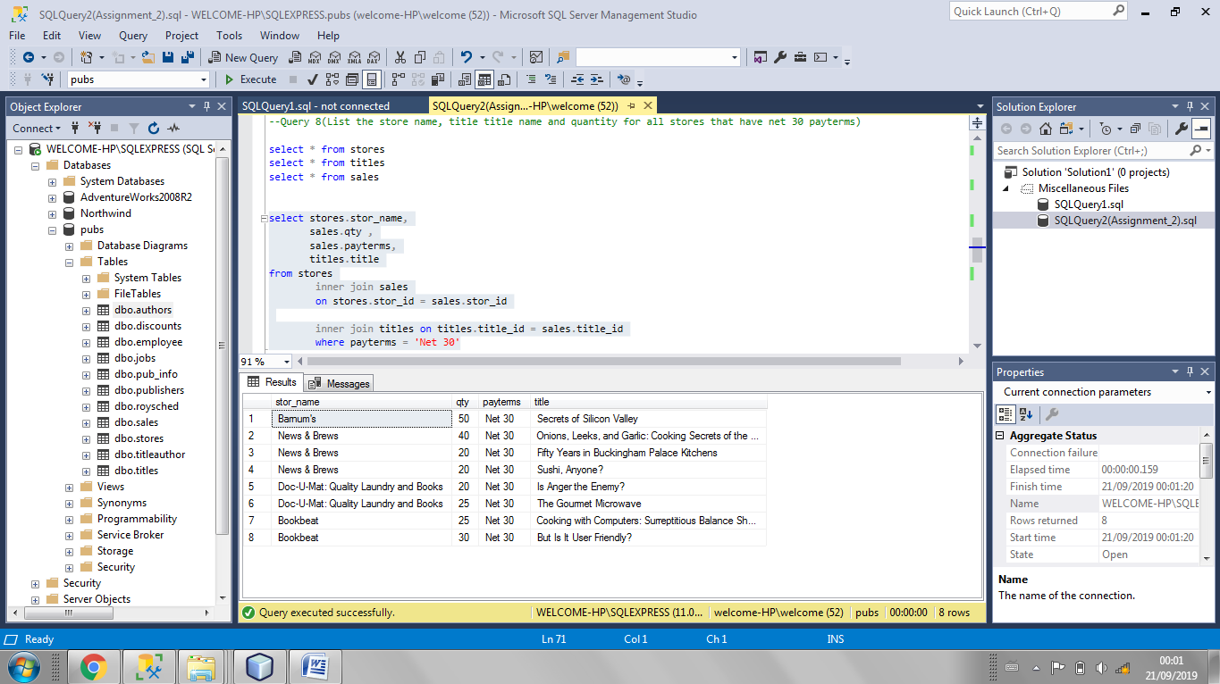

Query 9: Find the titles that do not have any sales show the name of the title

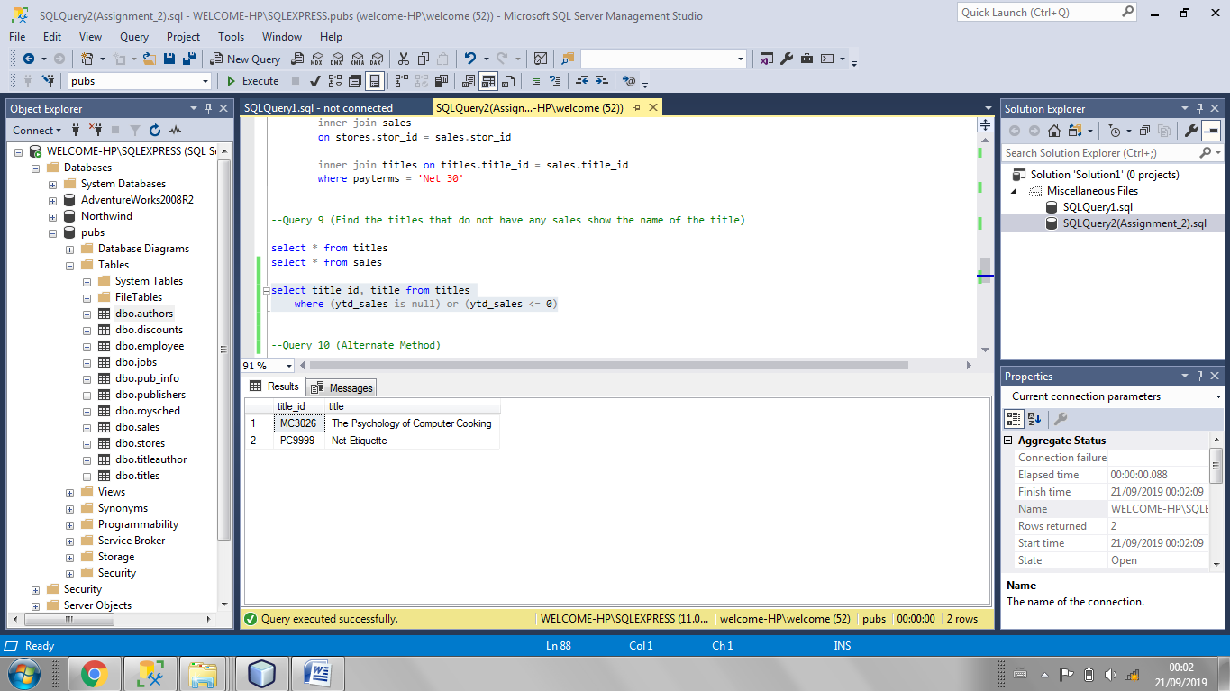

Query 10: Alternate method to solve Query 9

